stage@leeds information sheet
A Brief Introduction to Lighting
“Light or visible light is electromagnetic radiation within the portion of the electromagnetic spectrum that can be perceived by the human eye.^{[1]} Visible light is usually defined as having wavelengths in the range of 400–700 nanometres (nm), or 4.00 × 10⁻⁷ to 7.00 × 10⁻⁷ m, between the infrared (with longer wavelengths) and the ultraviolet (with shorter wavelengths).^{[2][3]} This wavelength means a frequency range of roughly 430–750 terahertz (THz).” - Wikipedia
“If dance is to theater what poetry is to literature, then light may be the haiku of dance poetics.” – Jean Rosenthal.
“Light is a material that has the ability to make a profound impact on audiences – it is not simply an illuminant but has meaning in and of itself.” – Scott Palmer
“The basic purpose of stage lighting, is to permit the performer to be seen by the audience” – Thomas Skelton
Lighting is not essential to theatre – but then neither is a physical theatre. A cast can gather on a field or hill or patch of green and enact a play. If you’ve ever seen open-air Shakespeare, for example, you’ll know this works very well – during the daytime. So, theatre needs a space… Perhaps you’ll have seen a sight specific play performed as the day slips into dusk, and perhaps a bonfire was lit so you could see the actors.
And there you have the introduction of lighting to theatre. The raging power of the bonfire, Socratic campfire shadows, the prompting of the eerie unknowns of night by the changing colours of the setting Sun.
As well as enabling us to see the actors, light serves to help define and/or create a space, to suggest a mood, to show and hide things, to guide the eyes. It can be used loudly, like a huge flashing Dance Music Concert, sparingly like a single flashing lightbulb illuminating the fridge-like walls of the Tate, brash like a follow-spot on a comedian, warm and comforting like a Pantomime at Christmas.
This brief document will give some ideas on basic lighting states, an introduction to various different lighting fixtures and a guide to what we have in stock in the stage@leeds theatres at the School of PCI.
Lighting States
There is no way I could show you how to light a performance on a single sheet of A4 paper. Or even a quire of A4. However, there are a few basic things worth noting.
The Intensity of the Light
The Placement of the Light
The Shape of the Beam
The Colour of the Light
Intensity
The lights, or lanterns, used in the theatres here at the School are generally connected to a lighting desk – we mostly use ETC Ion and Element desks. A desk simply enables the lighting operator to tell a specific lantern to shine at a specific intensity. These intensities are described as a value between 0 and 100. Different lanterns have different Intensities. We have small pin spots that are barely as bright as a candle, and 2000-watt floodlights that can illuminate a 10-metre x 10-meter theatre space single-handedly. The desk can then be programmed to recall that intensity at a later date.
Bright lights might help us see a whole scenario clearly. Softer lights might draw attention to detail. Tungsten lanterns are blinding white when on full intensity and dim down to warm off-white yellows and browns when less bright. Sometimes less is more and we want shadows to play on the walls and sometimes we want to see those teeth smiling…
Placement
Key light Fill light
Back light Side Light
Key light - is the term given to the light that picks out the subject. An actor is standing centre stage facing the audience. A spotlight positioned up and in front the actor throws light onto them, we can now see them. In most schools of lighting the key light would be positioned to hit the actor from slightly off to one side so as to create form. We might use more than one source for our key light.
Fill Light - is the term given to a secondary light source that supports the Key Light. It traditionally comes from an angle where it can be used to smooth out the shadows created by the Key Light. It is not so bright as the Key Light. If the Key Light was slightly to the right of the actor, the Fill Light would be slightly to the left, and vice-versa.
Back Light - A light source placed behind the subject helps to create three-dimensionality and defines the object/actor. Without Back Light the scene would be flat. You might be able to see a slight halo effect around the subject or actor when back lit.
With Key, Fill and Back lights we can build a basic state in which our actor appears representationally as ‘real’. These three lights mimic the effects of sunlight upon a person.
This is the standard 3-point lighting technique. You can see the Wikipedia example here
and here is an on-line example
https://www.mediacollege.com/lighting/three-point/simulator.html
Picture from Wikipedia https://en.wikipedia.org/wiki/Three-point_lighting
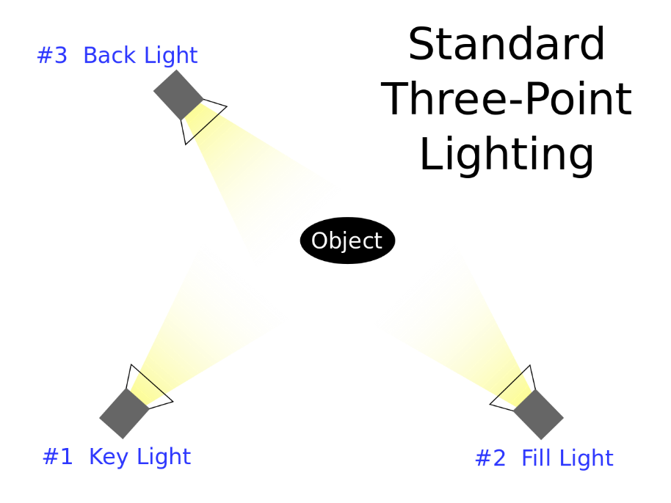
You’ll also see, if you visit the wiki page, a fourth light is often shown that does not illuminate the actor but instead is used to remove the shadows of the Key and Fill lights. That’s basic 4-point lighting.
So far so good, with three lanterns we can now present our actor/s in a satisfactory way, confident that we are following in the footsteps of theatrical giants.
We might use this technique multiple times on a stage to define different parts of the set.
Side Light - is the term for light from the side of our scene or actor/s. It can be used in conjunction with 3-point technique to augment the framing of the subject within a space – it can also be used on its own to highlight form, most notably in the world of dance.
Please refer to this fantastic photo-essay by the late great Jean Rosenthal for examples of side lighting states (and others). Rosenthal studied under Stanley McCandless.
https://hosting.iar.unicamp.br/lab/luz/ld/Diversos/Photo%20Essay%20.pdf
There is one copy of her book, The Magic of Light in the University Leeds Library. It’s worth a read. You can try and buy a copy, but it is very rare, and a second-hand edition would cost you over £100.
For further reading I’d also suggest looking towards McCandless. One of the great lighting theorists of the twentieth century. You’ll find him on the internet.
https://archive.org/details/methodoflighting00mcca/mode/2up
And while we are bothering the past masters of Dance Lighting, here is a series of articles by the late great Thomas Skelton
https://www.d.umn.edu/~mharvey/handbookofdancestagecraft.htm
Of course, we are not bound by these conventions. We might just want a backlight as an effect. But knowing where to start might help.

The Shape of the Beam
There are many kinds of lantern used in theatres, Pin-Spots, Birdies, Pars, Fresnels, PCs, UV Cannons, Codas, Blondies and Redheads, Profiles. We’ve had moving intelligent lights that can change position, colour and focus since the 1980s.
They all emit Electro-Magnetic Radiation which, if within the appropriate frequency range, can be picked up by the eye and brain and used to create sight.
These lanterns may have different shaped bodies, differently designed and powered lamps (‘bulbs’).
Focusing lenses may create a beam with specific shaping and hardness/ softness. Sometimes these parameters are adjustable.
We are currently in a time where the transition from Tungsten lamps (which emit light and heat) to a world of LED (which emit mostly light) is a very real and almost affordable proposition.
Leaving moving / intelligent lights aside for the moment let us look at the essentials.
Floods and Profiles.
Flood lights. These are lights that send out a big beam of EMR that literally floods the stage. They come in different sizes and here at the School we have them as small, 500-watt, standard, 100-watt, and big, 2000-watt. There are many different makes but for theatre we’re most likely to encounter the Fresnel.
The Fresnel is named after the Physicist and Civil Engineer Augustin-Jean Fresnel
https://en.wikipedia.org/wiki/Augustin-Jean_Fresnel
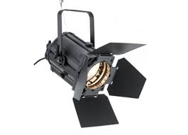
Monsieur Fresnel invented (amongst other things) a lens formed of concentric circles, like a lighthouse (for which it was designed) or a car headlight This lens projects a strong softish beam. By moving the illuminating lamp backwards and forwards the circular beam size can be increased or decreased. This lantern is very happy when used to create a big wash of light. We can alter the shape of the beam, very roughly, by using the barn doors that are situated at the front of the lantern.
and here is a Selecon Rama 1000-watt Fresnel lantern. You can see the barn doors are open and ready for business.

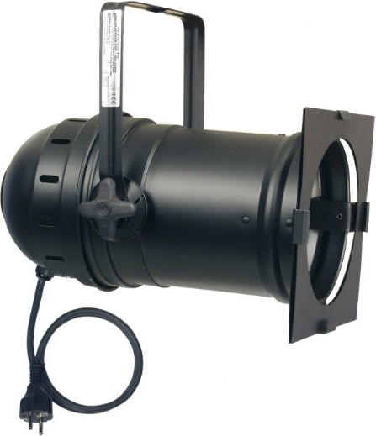
Par cans. A Par (Parabolic Aluminised Reflector lights) is a simple light with a large lamp that has a reflector and lens that create a strong oval beam of light that can be adjusted by spinning the lamp. Different lamps create wider or narrower beams – some look like Fresnels and others are smoother. These are relatively cheap and lightweight and great for creating washes of colour.
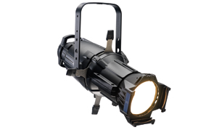
Profiles. These are lanterns that have a more directional approach. They can generally be focused better that floods. We have a range of units but our principal workhorse is the ETC Source 4 50-degree profile.
And here is one. You’ll see there are no barn doors. Instead 4 shutters are used to shape the light. The unaffected beam is a circle and we can create rectangular shapes with it, from squares to corridor-like strips, using these shutters. The beam can be focused sharp like a spot-light or soft, by moving the barrel backwards and forwards.

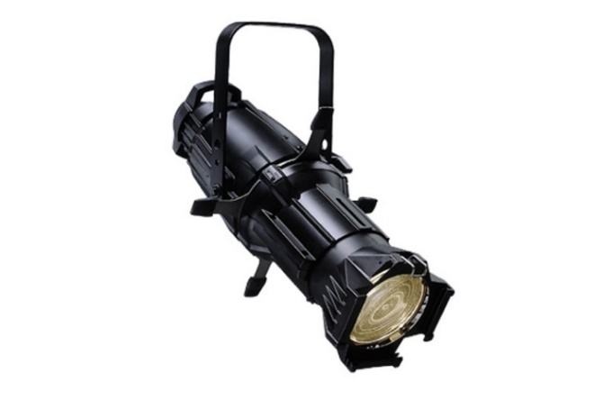
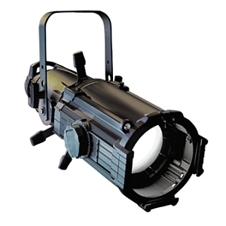
50-degree is the angle of the beam. We also have units with 19-degree beams and some at 26-degrees. Some of our lanterns have variable beams. Far left is a Source 4 Zoom profile with a variable beam. The smaller lantern on the right is a Source 4 Junior; also variable, but with a less bright lamp.

Profiles can be used to create a wash, and floods can be used as spots. Of course. The former with good results, the latter less so.

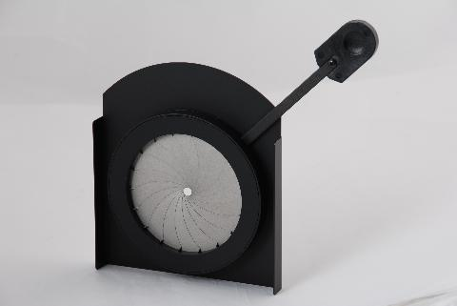
Iris and Gobos
Iris - Some profiles have a slot towards the lamp where an Iris can be inserted. This Iris can be adjusted so the beam can be made smaller, or tighter. This does away with having to hold many different graded barrels for the profiles in stock and allows the focus to be very much more precise.
When tightening the beam a certain amount of the EMR energy is lost as heat into the iris, but that’s the first law of thermodynamics for you.
We have irises for the source 4 profiles and they are widely used

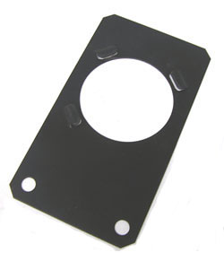
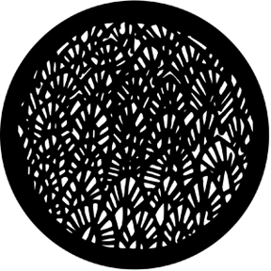
Gobo – Another add-on to the basic profile is the Gobo. This is a piece of steel, glass, or plastic that sits in a holder. The holder is placed between the lamp and the lens (hence the name GoBo, as it ‘goes between’) and the result then focused to fit. Here is a holder…
… and here is a Gobo – this one creates a ‘break up’ effect which can be focused sharp or soft – several profiles with break up Gobos and different coloured gel can create a textured feel to the set.
These come in many designs and can also be custom-made.
The one pictured here comes from the Roscoe catalogue which you can visit with the link below
https://us.rosco.com/en/products/family/gobos

WATCH OUT! Irises and Gobos, like anything Tungsten-lamp related, can get very hot indeed.
The Colour of the Light
Both the floods and the profiles can have coloured gel placed in a frame on the front of the lantern. This gel will block certain frequencies of EMR and thus change the colour of the emitted light. We mostly use Lee colour, but also Roscoe. As well as colour we can also use frost to soften and diffuse the light.
Here is a link to Lee Filters
https://www.leefilters.com/lighting/colour-list.html
Changing colours means we have an extra tool in our lighting design palette. We can suggest moods and temperature for performance areas to a much higher degree. We can create realistic representations of natural or man-made light, for example presenting the lantern’s white light through a gel that imitates moonlight, or we can create non-realistic swathes of colours that augment our performance.
There are methods to colour placement. McCandless suggested a warm wash on one side and a cooler on the other. He would use three colours and mix them when necessary to create more colour tones. Ballet for many years had strict rules on what colour went where.
We can do whatever we want with colour of course, we can create depth on an empty space with lavenders in the backlight and bright yellows at the front. We can make the space look cold with blue light or warm with oranges.
We can affect the mood of the audience.
There is some great academic writing about the effects of light.
One book you’ll find very useful is Scott Palmers Book ‘Light’
https://www.amazon.co.uk/Light-Readings-Theatre-Practice-Palmer/dp/0230551904

Some Basic Lighting Components
If you were to walk into stage one after a show has come down, you might struggle to grasp exactly what the lights up on the bridges were doing last. Shows can be end-on, thrust, traverse, immersive etcetera and lit accordingly. Step next door into the Alec Clegg and you’ll find that we always keep a generic plot up in the lighting rig. This plot is made up of a few key groups of lanterns. Assuming the show is end on /Proscenium we have:
Face Light
Wash
Side Lights
Back Wash
Specials
Face Light – a collection of profiles focused to cover the stage from the front. This is your Key Light and shines onto the actor’s face if they are looking at the audience; note we have a bank of them overlapping from different angles so as to also incorporate aspects of the Fill Light’s role.
Wash – a collection of floods that cover the whole stage from above. In the Clegg we generally use a 6-point wash, the stage area divided into six and each sixth lit by a Fresnel.
You’ll notice we have two washes up. One is gelled with a cool blue and the other with a warm gel, like a straw colour. These washes fill the whole space or individual lanterns within the washes can highlight areas of the space.
Side Lights – whilst not on boom bars like dance specific side-lighting, we have two banks of floods, one stage left and the other stage right, hung on the balcony bars. These act as a compromise between fill lights and pipe-ends.
Back Wash – a small bank of Parcans (Parabolic Aluminised Reflector lights) are used to provide back light. These are sometimes gelled with a deep blue to create the illusion of depth but often they’ll be lavender.
Specials – a special is an extra lantern to the generic rig. For example, you might want a pin spot up/stage/right to create a tiny pool of light for a flower. These can be added to the generic rig.
By combining these elements we can quickly and easily configure a simple lighting state, or collection of lighting states with the desk. These states can then be stored to the Lighting Desks memory as Cue States within a show file.

Moving Lights
As well as the Floods and profiles we have just looked at, the lighting designer has access to light units that can be told to move position and emit light in a variety of ways, changing colour and focus.

The earliest moving lights date back to the 1980s and a company called Vari-lite. You can read about them and how rock band Genesis invested £1million pounds into the company here.
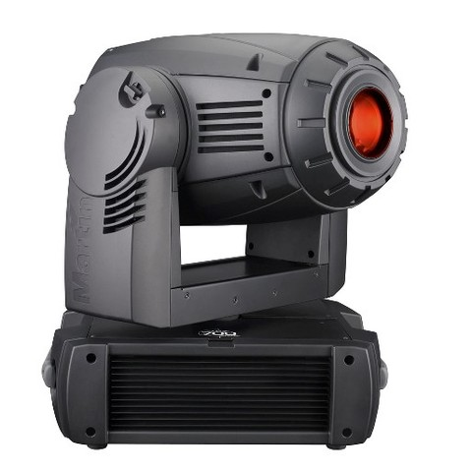
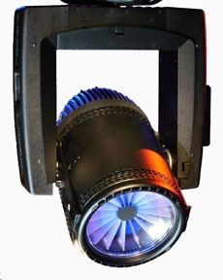
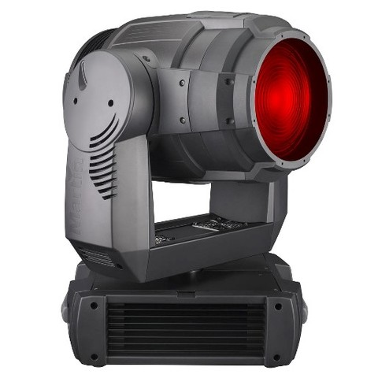
https://en.wikipedia.org/wiki/Vari-Lite
and we have one of the few remaining working examples of a bank of Vari-lites, the VL5 to be precise, in the Alec Clegg. These lanterns date back to the early 1990s and have a series of motors so they can be panned and tilted. They have a lens constructed of dichroic filters so the light can change colour, using Cyan. Magenta and Amber to mix a large palette of usable colour.
As well as sending intensity information to the moving light, we tell our lighting desk to send data instructing the pan and tilt of the unit, the beam size, the colour and the diffraction of the light. The lamp inside is a regular tungsten lamp that has been reinforced to endure the extra strains of movement.
Moving into the present we also have some modern moving lights
Here is the Martin TW1, which is best suited in the role of a flood. Like it’s older sister the VL5, it can be instructed to pan and tilt and to emit a beam of adjustable size and colour. We have 6 of these in permanent position in stage one – enough to create a wash of colour.
If a single coloured wash of tungsten lamps in stage one requires 9 Fresnels, to create three colours would demand 27 lanterns. Our 6 movers can do the same job much quicker; also individual movers can be used to define specific areas of the stage.
And here is the Mac 700 – we have 4 of these, again rigged permanently, in stage one. These lights work best as profiles and can deliver a hard, tight beam. As well as pan, tilt, colour selection and focus it also has a number of special effects built into it, like strobing and rotating. It has a bank of Gobos and can be programmed to perform a series of tricks.
Our moving lights currently are still based on Tungsten lamps, but we will see these being replaced by LED units in the near future.

