stage@leeds information sheet
Theatre Terminology
General Theatre Terms.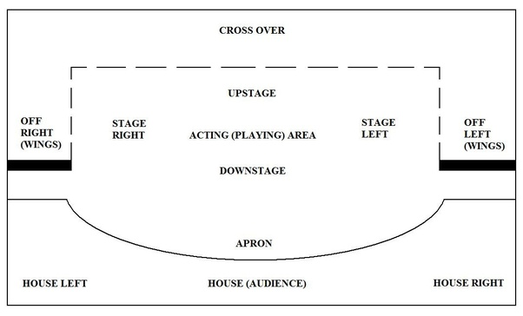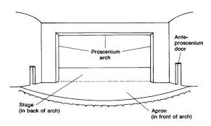
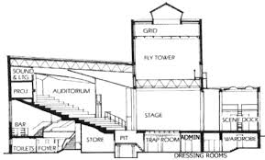
Boards: A slang term for the stage.
Apron: The bit of stage in front of the proscenium arch.
Proscenium Arch: The frame/ arch that the main house curtains are housed in, dividing the FOH and the stage area.
False Proscenium: A proscenium arch made from flats to mimic a proscenium arch.
Iron: The iron curtain that mechanically comes in if there is a fire. Stage side is metal the front is fabric. Usually it fills with water to make time for the audience to get out.
Stage Left: Left hand side from the actors view looking at the Audience.
Stage Right: Right hand side from the actors view looking at the Audience.
Upstage: Towards the back of the stage, away from the Audience.
Down Stage: Towards the front of the stage, towards the audience.
PS: (Prompt Side) normally stage left (Britain) (stage right US).
OP: (Opposite Prompt) Opposite of above.
BS: (Bastard Side) Where the Prompt side is on stage right.
O.B (Opposite Bastard) Opposite of above.
FOH: (Front of House) Anything in front of the Main House Curtains.
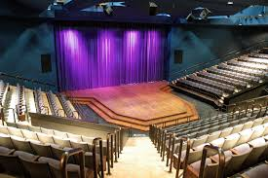
Vom. (Vomitory): is a passage situated below or behind a tier of seats in a theatre, an amphitheatre or a stadium, through which big crowds can exit rapidly at the end of a performance. They can also be pathways for actors to enter and leave stage.
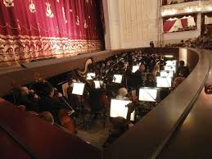
Orchestra Pit: Usually at the front of the stage housing the orchestra, allowing the conductor to see the stage but keeping the orchestra out of the sight lines of the audience.
Wings: The side of the stage that the actors make their entrances from. (Usually masked by legs from the audience).
Rake: This is the gradient that the seats or the stage are set at.
Back Stage: Everything behind the proscenium arch that the audience cannot see.
On Stage: Everything that the audience can see.
Scene Dock: Usually a back stage area where set is stored ready to go onto the stage.
Green Room: An area back stage where actors and stage crew can relax, have a drink etc.
Dressing Room: Where actors get dressed and costumes are stored for the show.
Crossover: Allows actors to get from one side of the stage to the other without being seen.
Sight Lines: The lines of sight that all the seat positions of the audience can see onto the stage. (Very important if you do not wish them to see something).
Grid: Lighting grid, where the lights are hung.
Gantry: Metal walkway that you can focus the lights from.Wardrobe: Anything to do with costume, where costumes are made and fitted.On Stage.
Tabs: Curtains.
House Tabs: Main Curtains that come in at the end of the show (Usually Red Velvet).
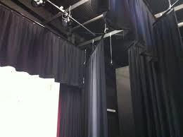
Border: Black curtain about 2m in height that frame the stage and help hide the lights above the stage.
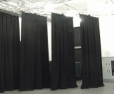
Leg(s): this has two meanings:-
1. Curtains that mask off the side of the stage creating Wing space.
2. Scaffold Bar that goes into Decking to lift it to height.
Blacks: Blackout curtains. Usually used for masking. (The legs above are blackout material).
Slit Drape: Usually a backdrop like the plastic strips you have in your doorway to keep flies out during the summer.
Back Drop: A Cloth that is hung at the back of the stage (upstage).
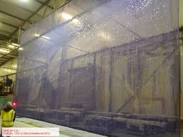
Gauze: A fine meshed cloth. When lit from the front it appears solid, but when lit from the back you can see through it.
Scrim: Wide mesh cloth usually not that well made. Used in set dressing. Like hessian, sand bag material, but not as tightly woven.
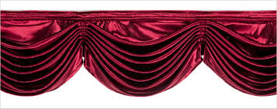
Swag: This is done to curtains to put folds into them to make them look swish. It’s like what you do to your domestic curtains when you tie them back.
Masking: Either cloths or flats that stop the audience from seeing that which you do not want them to see. (Sight Lines).
Tech Stuff.
LX: Lighting.
Going Dark: A warning to everyone that the theatre is about to have its lights turned off.
Dim Out: When you fade out on the lighting board, you don’t quite go to black out.
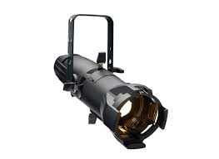
Profile: Tight beam of light.
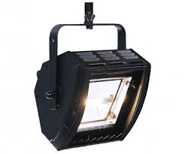
Flood: Wide beam of light. (Flooding the entire area no control). 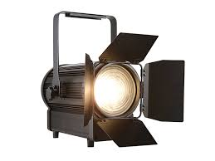
Fresnel: Half way between a spot and a flood.
FX: Sound (today it includes projection).
Cross Fade: To fade from one lighting state to another or one sound effect to another
God Mic: A mic for the director to use, so that they can talk to everyone on stage.
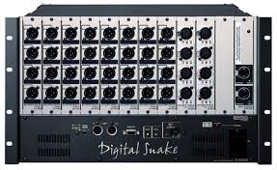
Digital Snake: This is a unit that has multiple inputs and outputs, that plugs into the side on the stage via Ethernet cable and is connected by a receiver to the sound desk.
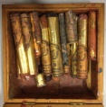
Grease Paint: Special make up in stick form, which is used in theatres.
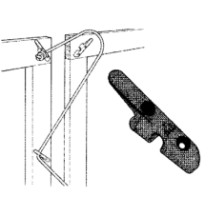
Clummet: A cleat that has a notch in the back that can have a rope attached.
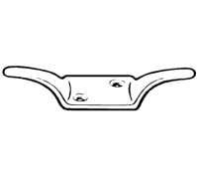
Cleat: A metal hook usually double ended so that a rope can be wound round it, tying the rope off without having to tie a knot.
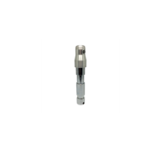
Spigot: A shaped tubular piece of metal with a thread at one end to take a bolt that allows a light to be put on a lighting stand.
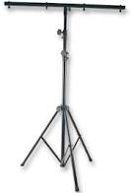
Tree: Lighting stand.

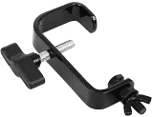

Hook Clamp: A clamp that allows a light to be suspended from truss or Scaffolding bar.

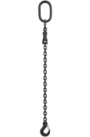

Safety Chain: Anything flown should have a safety chain on it as a secondary attachment, in case the primary fixing fails. Lights should always have these. They can be chains or steel ropes. They allow some movement for focusing.

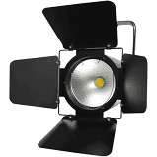
Barn Door: The metal shutters on the lens end of a light.

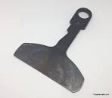
Shutter: The internal metal shutters half way along the body of a profile.

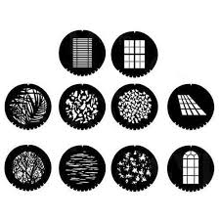
Gobo: A metal disc with a pattern cut out of its middle that fits into a light to make a pattern on the floor.
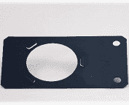
Gobo Holder: Holds a gobo. Makes a gobo fit into a specific light.
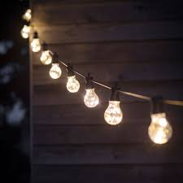
Festoon: A cable with multiple lamp holders in it, usually used for outside events.

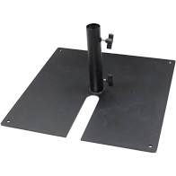
Tank Trap: The weighted base of a Boom stand.

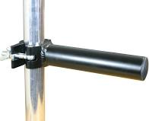
Boom: An arm at right angles to a bar or stand that allows lights to be hung.
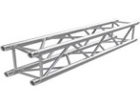
Truss: A strong rated structure that allows set and or lights to be hung safely.

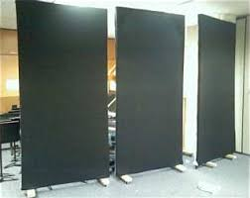
Flats: Scenery that can either be solid wood or canvas that can be painted to
Look like solid objects, but are light enough to move on stage.
French Man: Flats that are flown.
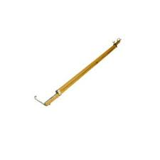
Stage Brace: Temporary bracing that holds flats up.

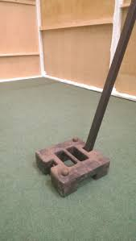
Stage Weight: A weight that fits a stage brace.

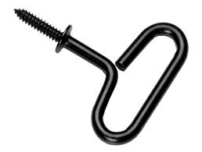
Stage Screw: A screw that screws into the stage that hold a stage brace up instead of a weight. It has a handle on it so that it is easy to use. (No tools).

Ground Brace: A wooden brace that attaches to a set and then can be screwed down or weighted down. (See A below)
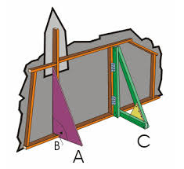
French Brace: A wooden brace that is attached permanently attached to a flat that is hinged so it can be folded back, to aid scene changes. (C shows the hinges).
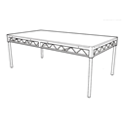
Decking: Blocks that can be bolted together to make raised areas of stage area.

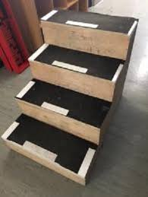
Treads: Steps going up to raised levels on a set.
Trucks: Pieces of interactive set on wheels.

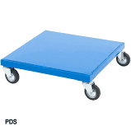
Dollies: Boards or boxes on wheels.

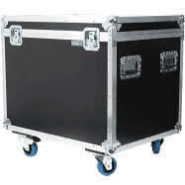
Flight Case: Strong, light weight box for transporting fragile equipment. E.g. Sound desks. Usually they are on wheels.
Fly: To fly a piece of set etc. In the air. E.g. on ropes.

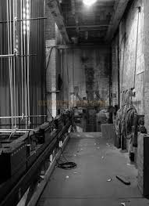
Flies: Where the controls for flying cloths and set are, usually today counterweight system is operated and the ropes are now steel ropes. 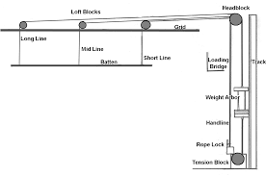
Long: The rope that travels the furthest from the Flies.
Middle: The middle rope.
Short: The shortest rope.
Dead: This is what you set the flying ropes to ensure a cloth are set is level and at the right height on the stage.
Brail line: This is a second line that is attached to another rope to pull the rope into the right position. Usually horizontal to the first.
Spot Line: This is a line that can help hold up an object on stage, or temporarily lift something into position, prior to permanent fixing.
Drift: The rope that goes from a bar to the top of a piece of set, that allows the set to be in position, but allows the bar to still be hidden.

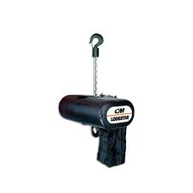
Hoist: A mechanical geared device for lifting heavy weights. Can be electrical.
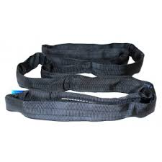
Sling: A rated material loop for lifting.

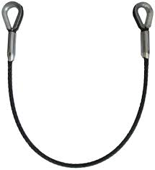
Steel: A rated steel rope used for safety and lifting.
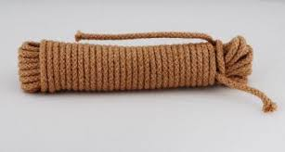
Sash: Thin rope about 6mm to 8mm thick. Originally used in sash windows.
Set: “Setting” Flats, decking, painted cloths, etc. Put onto the stage to create a picture of where the action is supposed to be happening. E.g. House, Office or Railway Station.
Props: “Properties” These are smaller items that help set the scene. E.g. Brushes, Umbrellas, Handbags, Briefcases.
Bible: Prompt book. It’s the script that runs the show. Everything runs to that, it brings the acting and technical together.
Barrel: (Bar) Scaffold Bar.
Blues: Back stage (blue) working lights, so that actors can safely move around the set back stage.
Cleaners: Auditorium working lights.
Anti Rake: When a stage is raked it is sometimes necessary to make the set stand flat or vertical and therefore needs to be anti-raked.

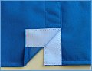
Drugget: A stage cloth. It is a cloth that covers the stage.

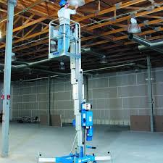
Genie: A mobile platform for working at height.
House: This means either the audience or the auditorium.
In Set: A small scene set inside a bigger one. Works in acting terms and scenic terms.

People abbreviations.
PM: Production Manager.
CSM: Company Stage Manager.
SM: Stage Manager.
ASM: Assistant Stage Manager.
TSM: Touring Stage Manager. (Person who might call the show, especially if it is only on for one night)
DSM: Deputy Stage Manager. (Person who normally calls the show).

