Constructing a lighting plan
A well detailed lighting plan is an invaluable document and helps the lighting designer share their concept with the Director and technical team. Combined with a hook-up list, it helps enormously when it comes to the task of rigging the lanterns in the physical space.
here is an example.
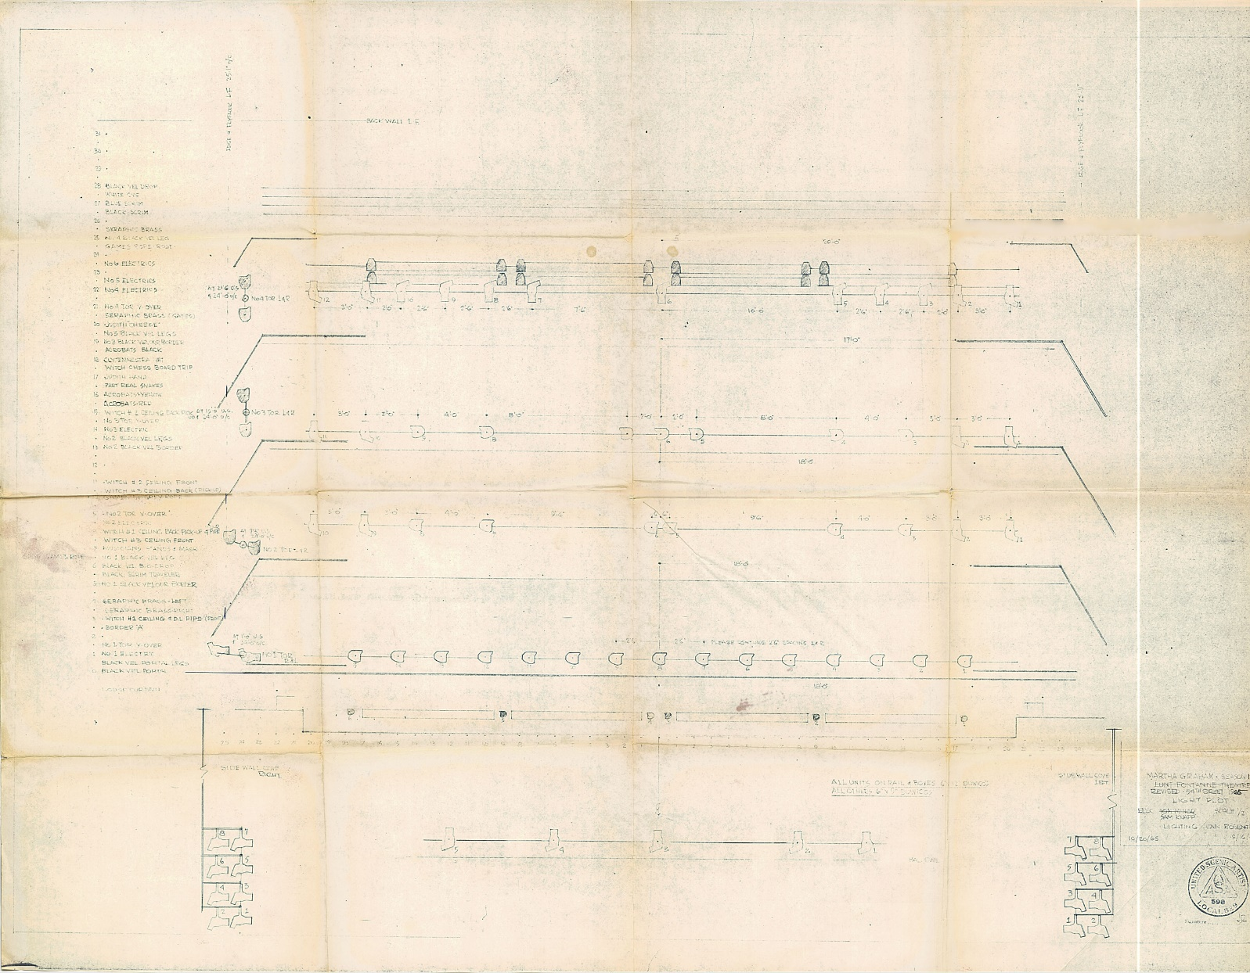
- Jean Rosenthal, plot for Night Journey, Martha Graham Dance Company, 1965.
from http://thelightingarchive.org/show.php?show_id=11
Here we can see a visual representation of the stage and lighting bars, and representations of the required lanterns, and a description and key.

To create a plan we first need to know how the space is equipped with lighting positions, bars etc, and what lanterns we have available to us.
at stage@leeds we can find this information on Minerva; namely the technical specifications (which list available lanterns, lighting desk etc) and the floor plans.
These are found at Minerva/ School Area/stage@leeds/venue specifications
Assuming we are using The Alec Clegg as our performance space
And a design concept has been created. One methodology might be…
Make a list of what is needed: This list will be our Hook Up List.
E.G.

Actors to be lit across whole of stage, daytime and night-time
a pool of light centre stage
thunder and lightning effect
a living room area USR
Disco lights

We can then estimate what lights we need to use:
This creates our Hook Up List
Front lights from the gantry using 4 x Acclaim Profiles O/W
A daylight wash using 6 x Fresnels L764 Sun Coloured Straw
A moonlight wash using 6 x Fresnels L603 Moonlight White
A neutral backlight using 2 x 2,000w Fresnels - L052 Lavender
Side light from S/R and S/L using 8 parcans - L021 Gold Amber
a flashing effect using a strobe hired in from a third party
a pool of light 1 x 50-degree source 4 profile
a living room light 1 x pendent
A square 4 x 50 degree source 4 profiles
flashing moving lights using 4 x VL5
A disco ball lit by 2 x source 4 Junior 26-degree lanterns O/W
house lights 2 x 500w Fresnels

These lanterns are numbered
They also have circuit numbers - the physical address of the sockets on the bars that will be used. We can show these on our diagram…
so each lantern will have a circuit number, and a plan number. Some will also have codes for the sort of gel they will be equipped with.

Front lights from the gantry using 4 x Acclaim Profiles O/W
circuits 68, 96, 71, 72 lamps # 1, 2, 3, 4
A daylight wash using 6 x Fresnels - L764 Sun Coloured Straw
circuits 22, 29, 32, 39, 42, 49 lamps # 5, 6, 7, 8, 9, 10
A moonlight wash using 6 x Fresnels - L183 Moonlight Blue
circuits 23, 29, 33, 39, 42, 49 lamps 11, 12, 13, 14, 15, 16
A neutral backlight using 2 x 2,000w Fresnels - L052 Lavender
circuits54, 58 lamps 17, 18
Side light from S/R and S/L using 8 parcans - L021 Gold Amber
circuits 84, 85, 88, 90, 73, 91, 92, 94 lamps 19, 20, 21, 22, 23, 24, 25, 26
a flashing effect using a strobe hired in from a third party – DMX 500
a living room light 1 x pendent
circuit 44 lamp 27
A pool of light 1 x 50 degree source 4 profile
circuit 28 lamp 28
A square 4 x 50-degree source 4 profiles
circuit 27, 31, 40, 55 lamps 29, 30. 31, 32
flashing moving lights using 4 x VL5 lamps 301, 302, 303, 304
A disco ball lit by 2 x source 4 Junior 26-degree lanterns O/W
circuit 95 lamps 33
House lights 2 x 500w Fresnels
circuit 14 lamps 100
We can represent these using a pencil and drawing symbols. Students can do this on a print-out of a lighting plan – the plans are on Minerva/ School Area/ stage@leeds/Venue specifications
This is perfectly acceptable, see Jean Rosenthal’s hand-drafted plan at the top of this article.

Or, using available software, we can represent these on a plan like this:
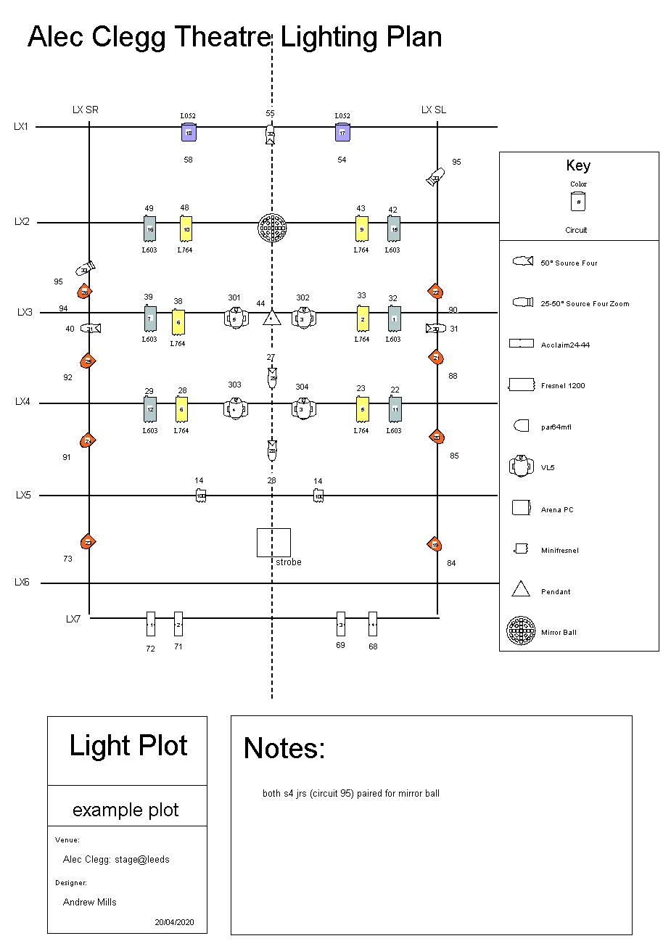
here we have a physical representation of the lighting bars, populated with lanterns.
The key is used to identify which units are being used and the lantern number, circuit and gel type are also identified. 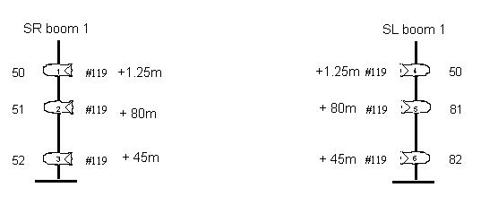
Here is an example of two boom bars. Lantern number, circuit number, frost designation (#119 is Roscoe Half Hamburg Frost) and distances from the ground the boom arms are to be set at.

